Scalefocus DevOps Academy Midterm – Marko Mihajlov

Mid-Term Task

Part I

1. Host a static website on Blob Storage: build and deploy a static Hello

World website to Azure Storage.

We are starting the lab with creating a resource group for the exercise and a storage account for hosting the static webpage on Blob(binary large object) storage.

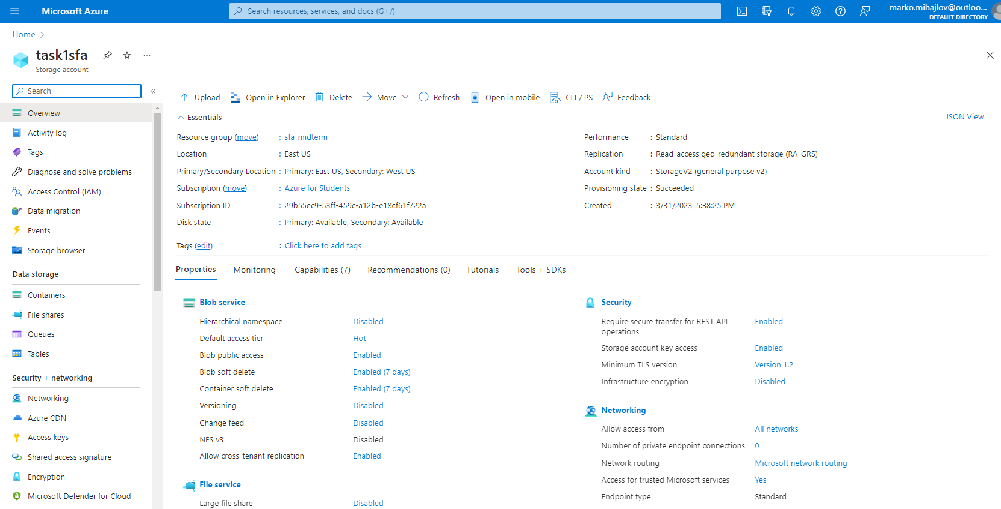

Reviewing the created storage account, situated in the Resource group created for this task sfa-midterm.

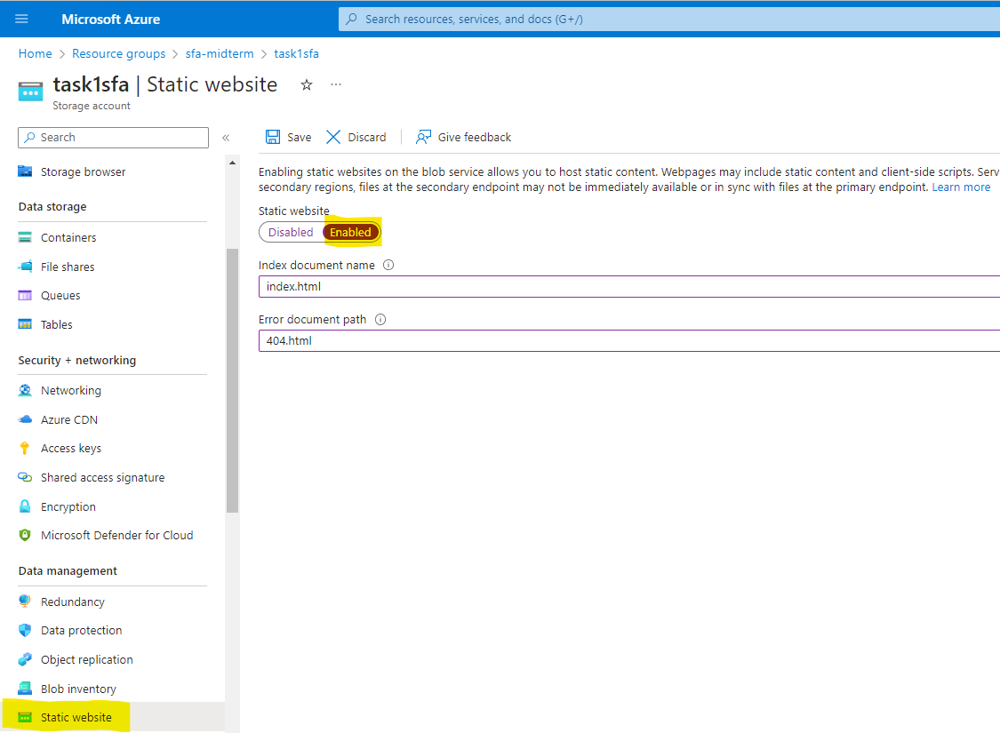

Going into the static website blade on the task1sfa storage account and enabling hosting of static website content on the storage account.

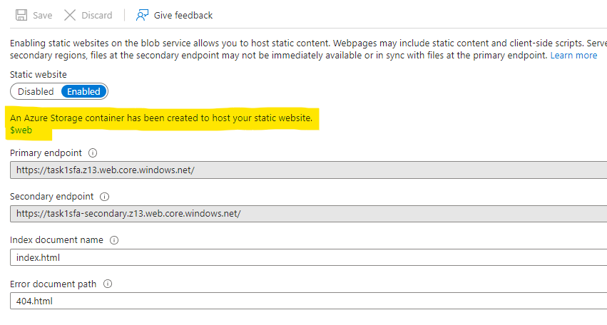

Afterwards we receive a notification that an container has been created to host the static webpage.

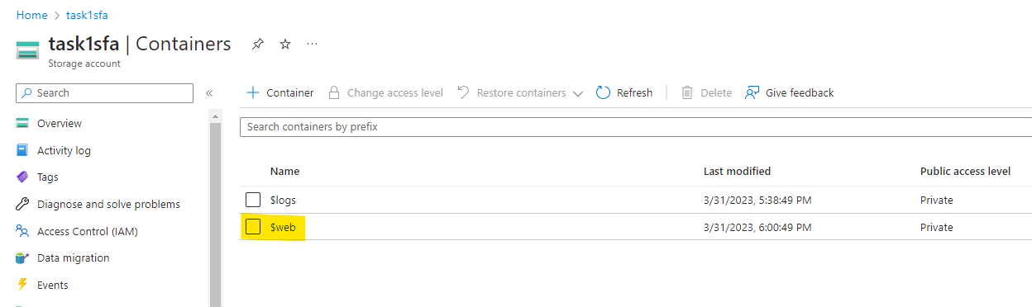

The container in question ($web).

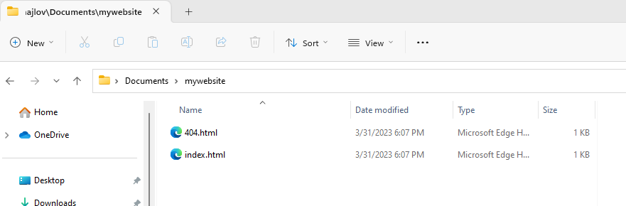

Next step is to create a local folder on our machine in which we will create the content for the website through an editor or in this case VS code and deploy them through to the container through VS code.

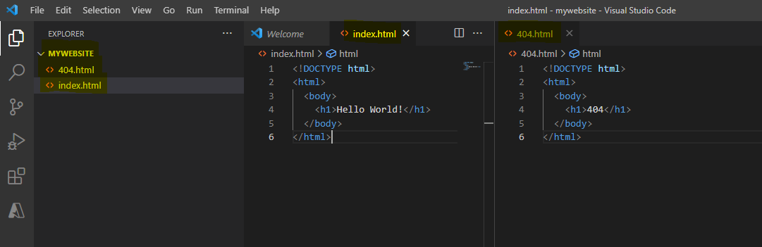

Process of creating the default content page and error page.

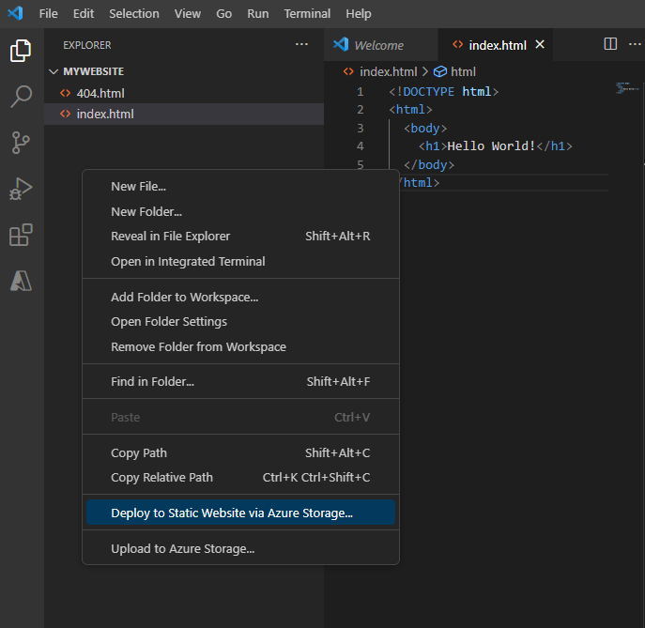

Deploying the static website using Azure Storage via built in function in Vs Code.

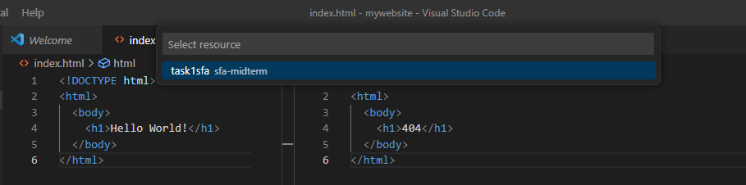

After being promted to log in Azure and to select the subscription in which the storage account is under ( Azure for students in this occasion ) we are prompted to select the storage account where the container $web is located.

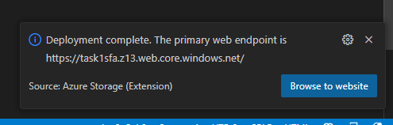

After the successful deployment we are presented with the primary endpoint, which note is the same as when we created the $web container with which we confirm that the location is correct.

2. Verify that the default web page has the Hello World! page.

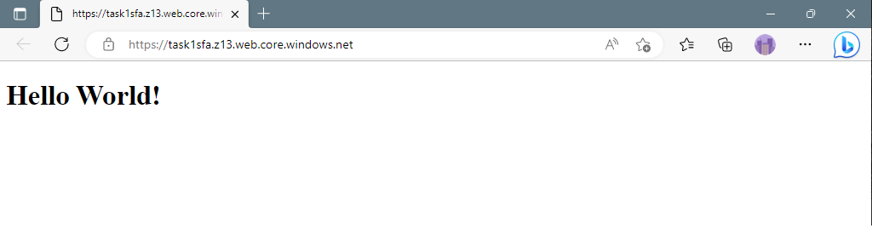

After visiting the provided URL we are greeted with the default landing page of our static webpage.

End or part 1

Part II - In this exercise we will setup a Linux based web server and will deploy a web page on it.

1. Create a Virtual Network where you will deploy your Linux Based Web Server.

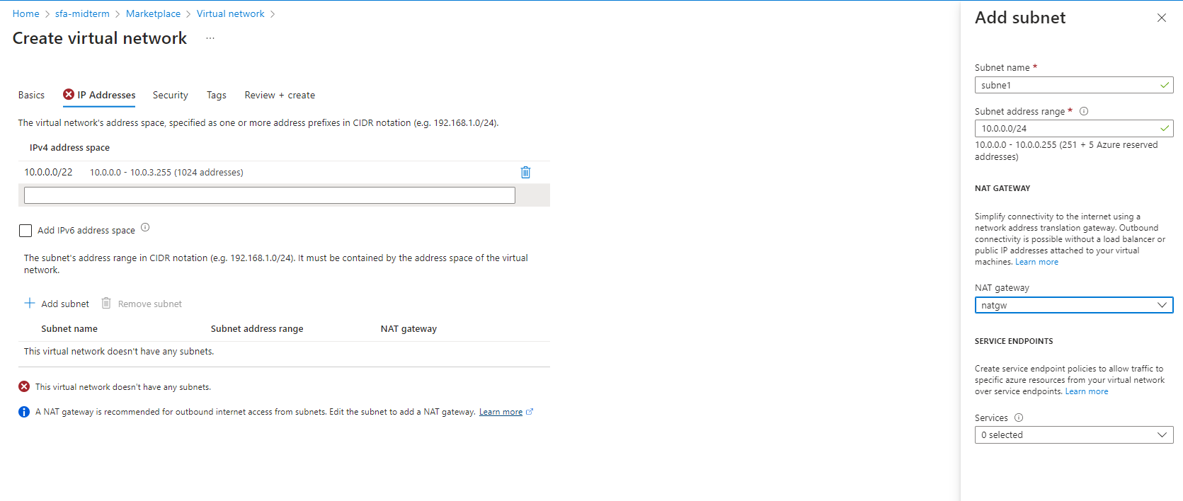

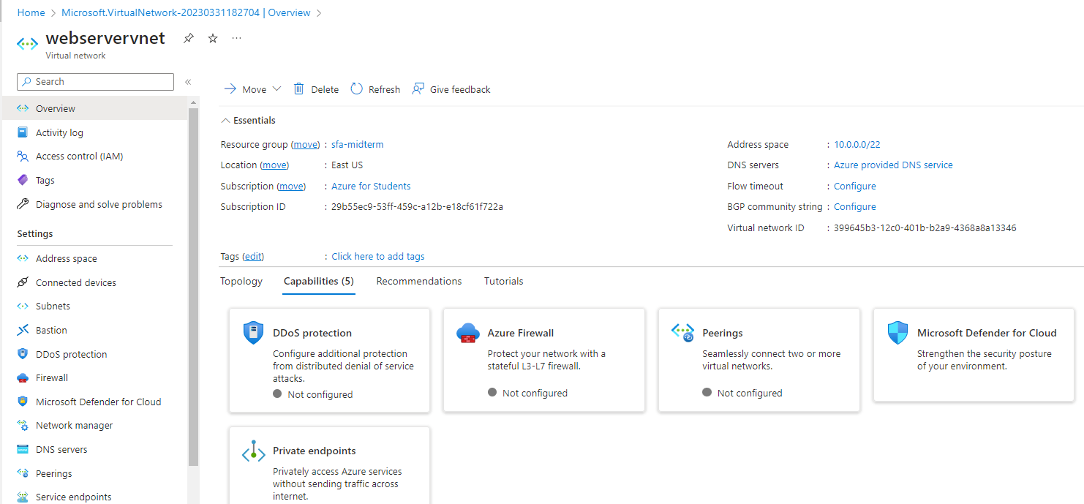

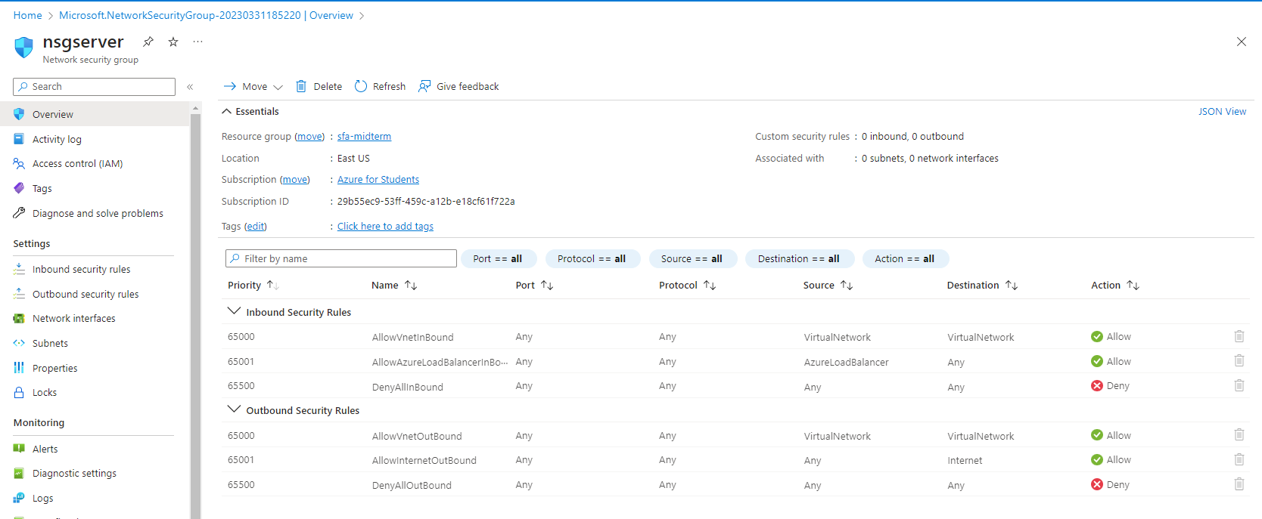

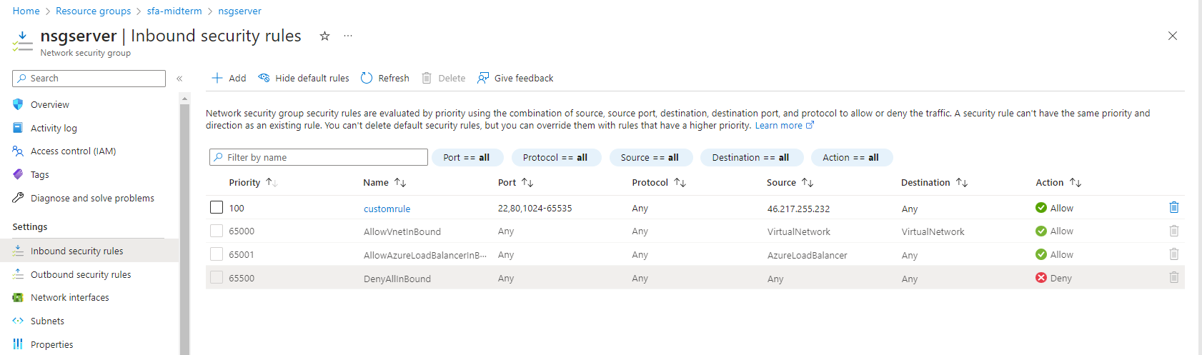

Modifying the nsg to accept incoming iconnection only from my ip and with priority above the default deny all rule.

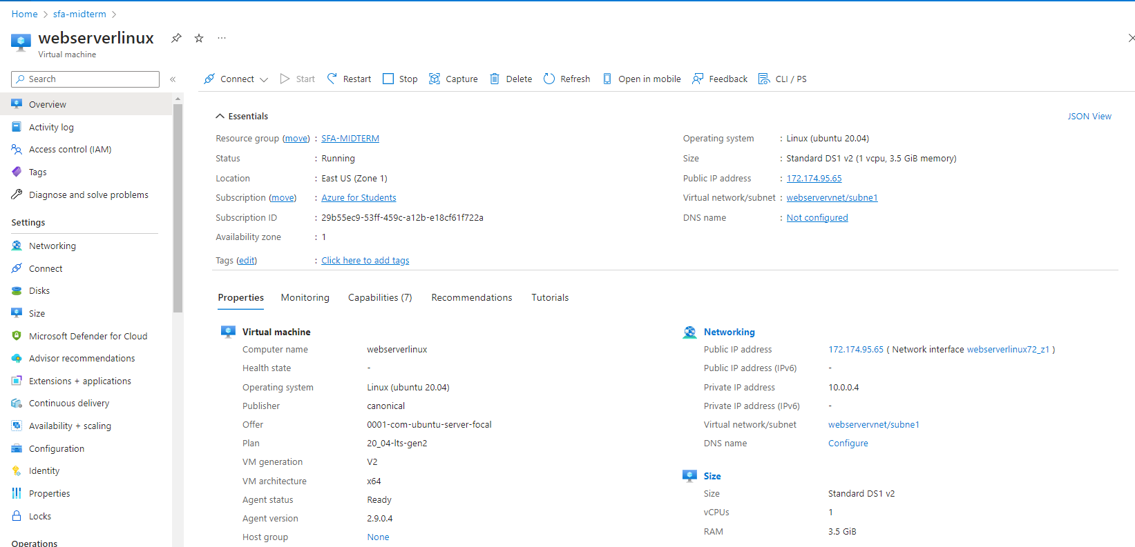

The created virtual machine with public ip interface to connect to.

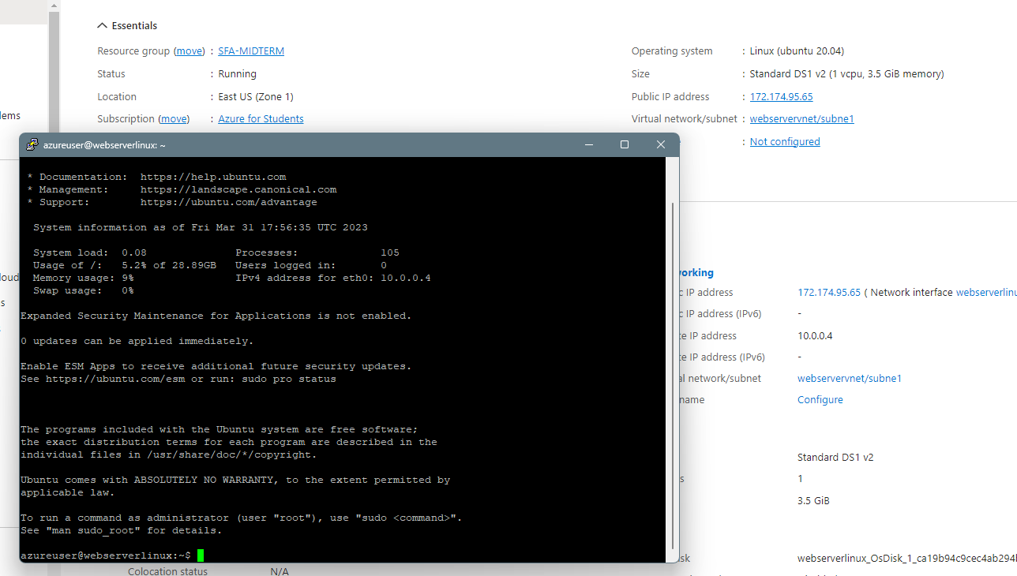

Connecting to the VM via putty.

Did not install services on the VM,

Could not test connectivity to VM controlled by nsg

Marko Mihajlov